**\*\*IF YOU HAVE ANY TROUBLE READING THESE, PLEASE LET ME KNOW. I AM BRINGING THE PAPER VERSIONS WITH ME TO CLASS JUST IN CASE. I SPENT A LOT OF TIME ON THIS SO IF IT’S HARD TO READ PLEASE LET ME KNOW**  
1) Subset(15,[2,3,4,7,10,42])**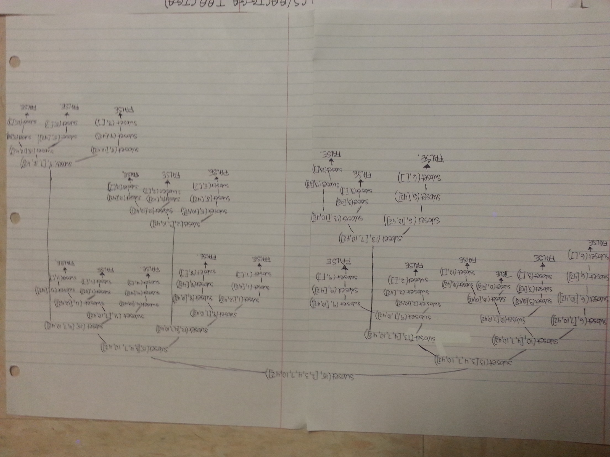

**2) LCS(“AACTGGA”, “TAACTGA”) (left side of hierarchy in first image, right side in second)**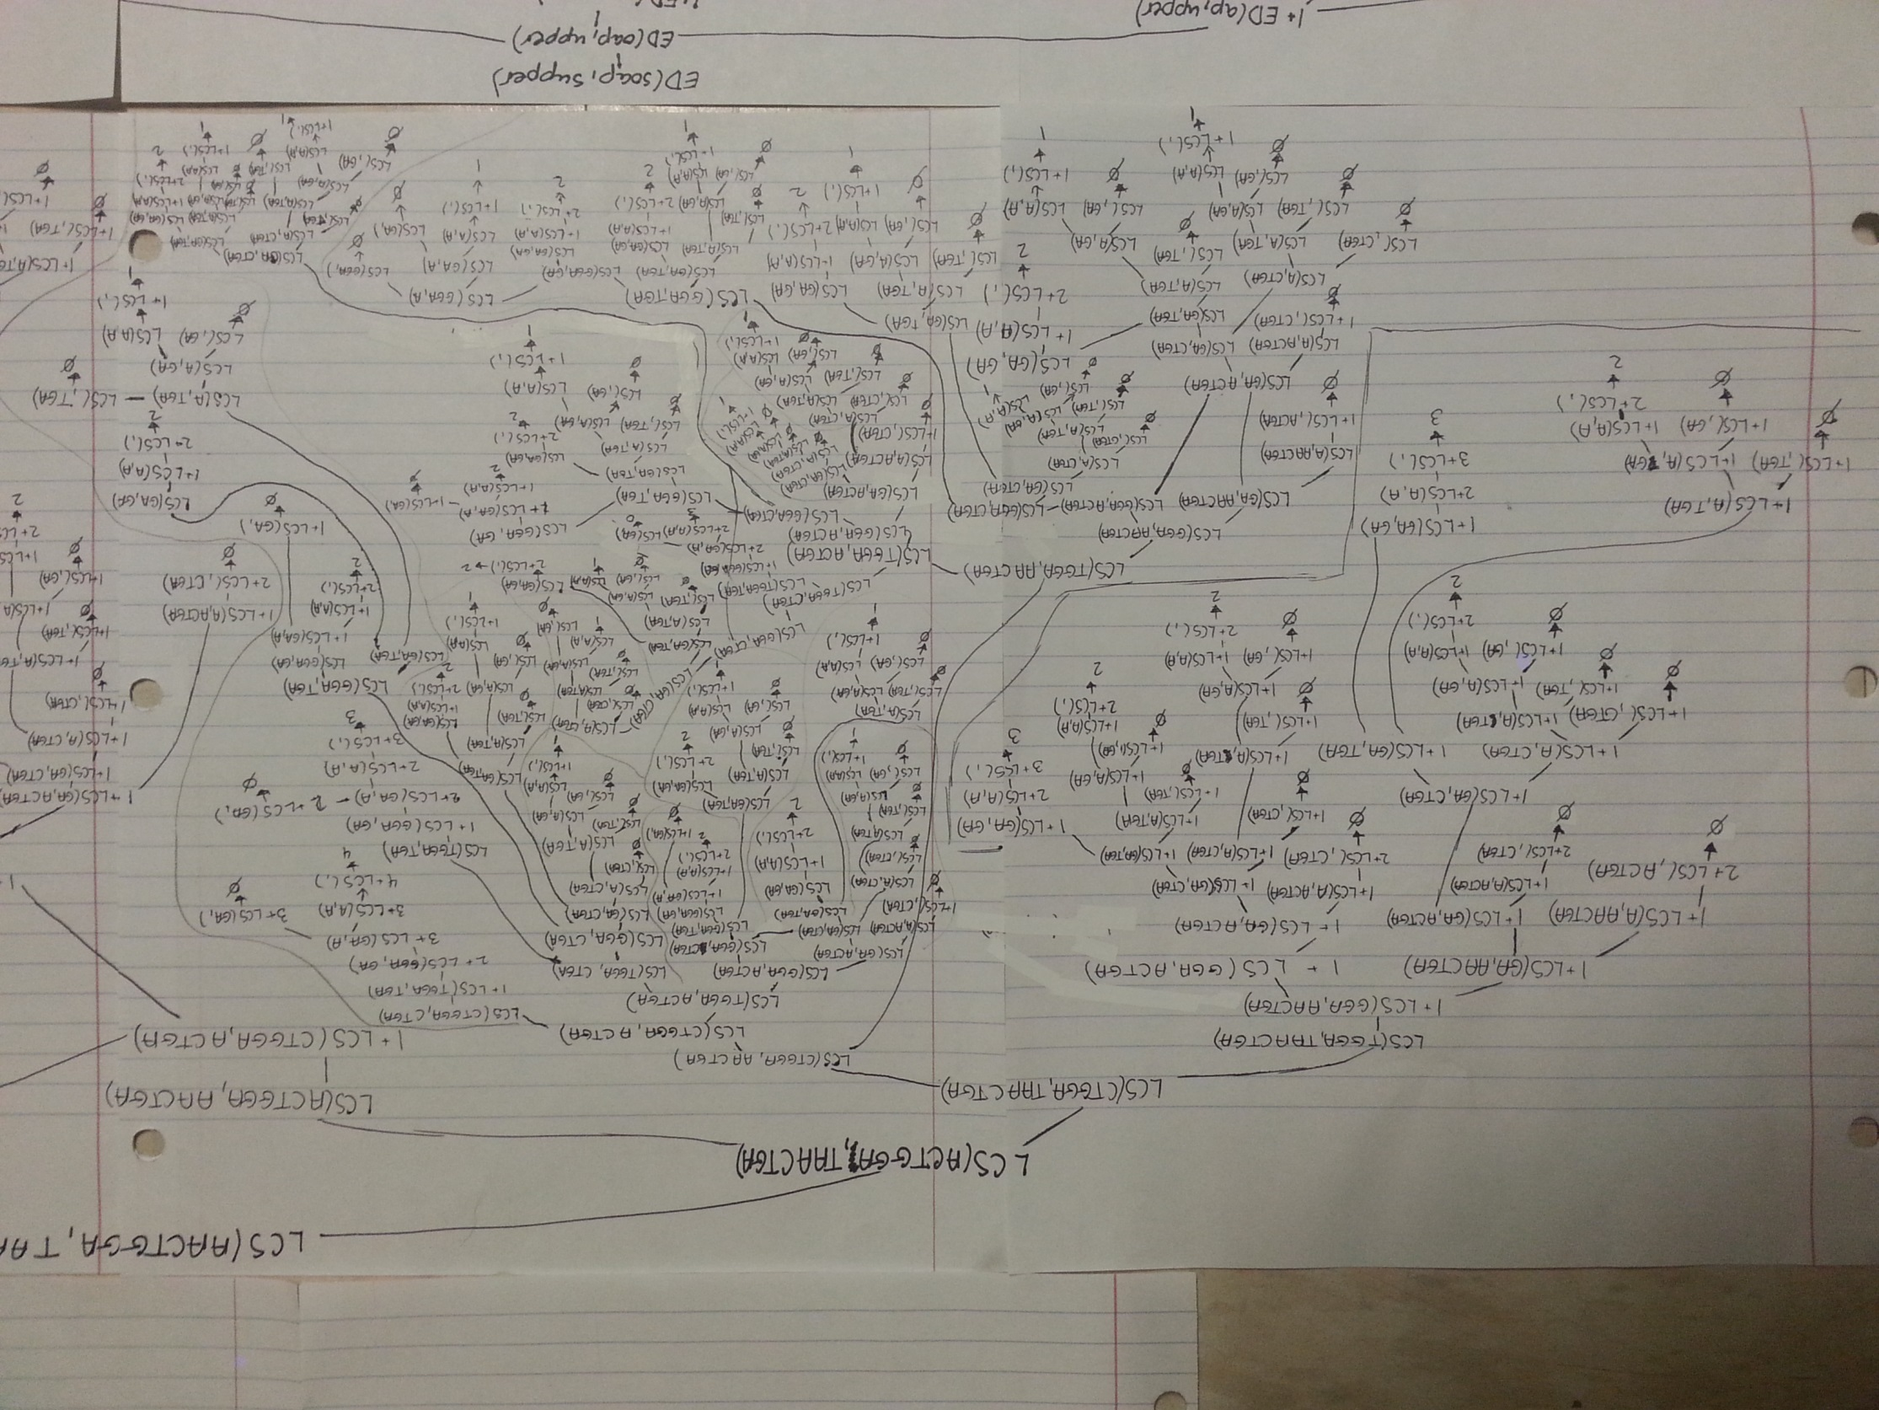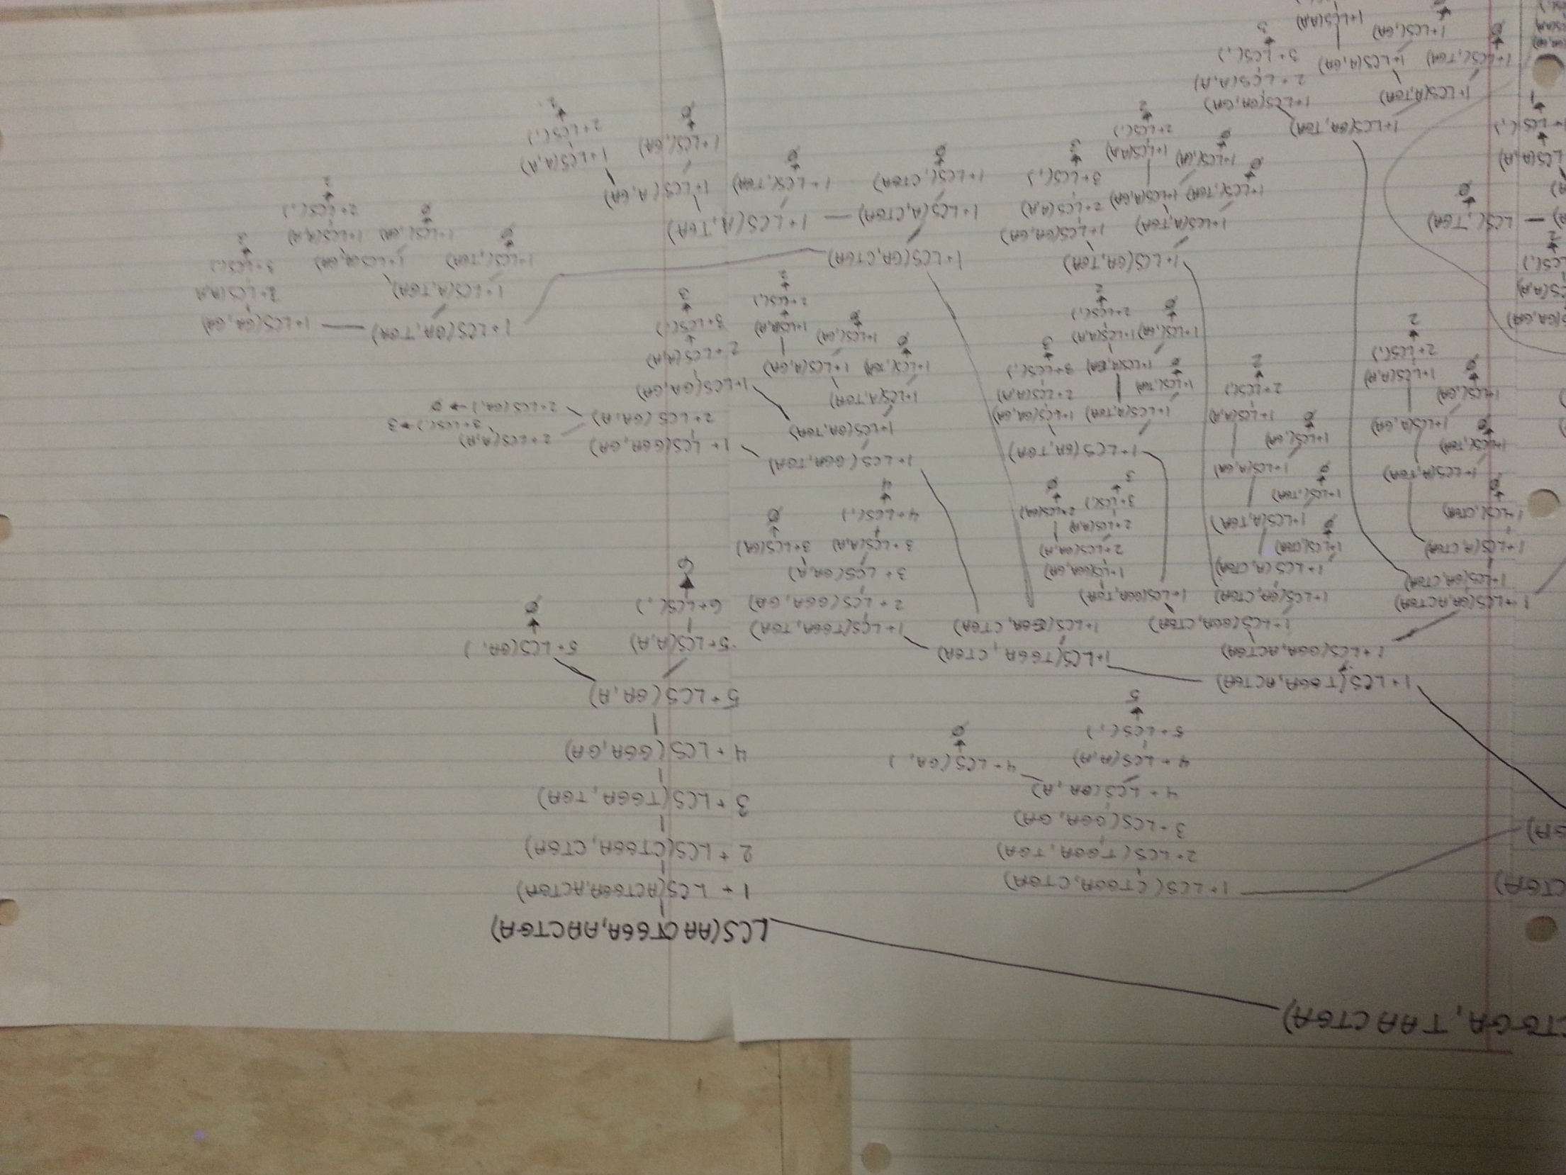

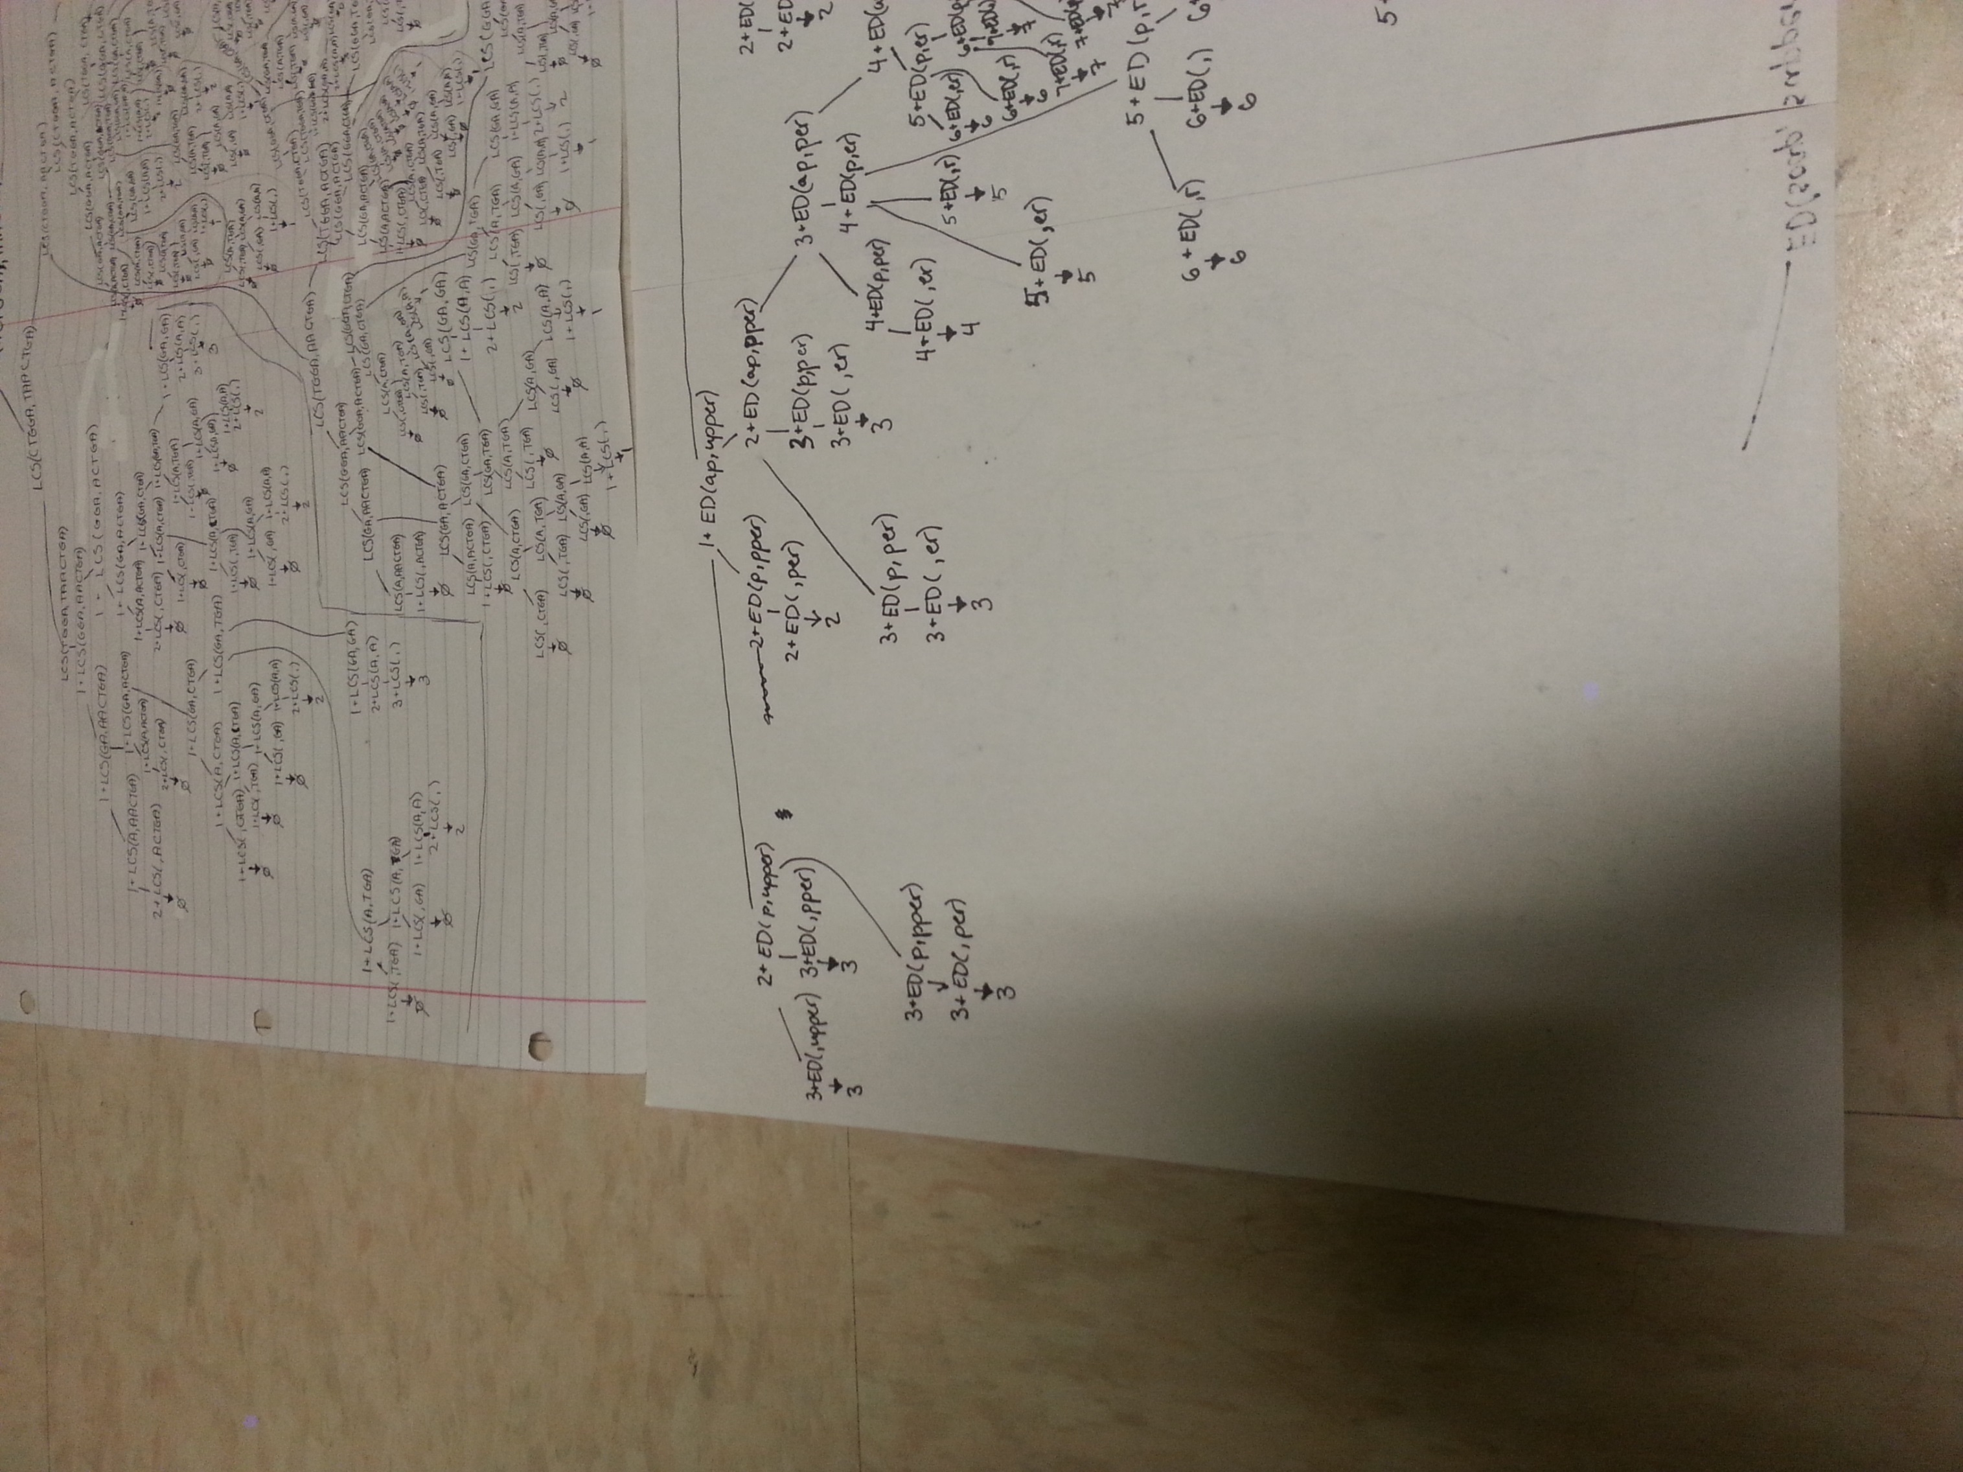**3) ED(soap, supper) Split into the following 4 pictures**

